Introduction
Pollution, an ever-growing menace, poses significant threats to our planet and its inhabitants. It is the introduction of harmful substances or products into the environment, leading to adverse changes that affect all forms of life.

Air Pollution
Air pollution, primarily caused by industrial emissions, vehicle exhausts, and the burning of fossil fuels, leads to severe health problems such as respiratory diseases, cardiovascular issues, and even cancer. The release of greenhouse gases, particularly carbon dioxide, contributes to global warming and climate change, resulting in extreme weather conditions, melting glaciers, and rising sea levels.

Water Pollution
Water pollution, caused by the discharge of pollutants into rivers, lakes, and oceans, endangers aquatic life and contaminates drinking water sources. Industrial waste, agricultural runoff, and plastic debris are the main culprits. The presence of toxic chemicals and heavy metals in water bodies can lead to the death of marine organisms, disrupt ecosystems, and pose health risks to humans who consume contaminated water or seafood.

Soil Pollution
Soil pollution, primarily due to the use of chemical fertilizers, pesticides, and the disposal of industrial waste, degrades soil quality and reduces agricultural productivity. Contaminated soil can lead to the accumulation of harmful substances in crops, affecting food safety and human health. Additionally, soil erosion and loss of fertile land contribute to desertification and habitat loss.

Conclusion
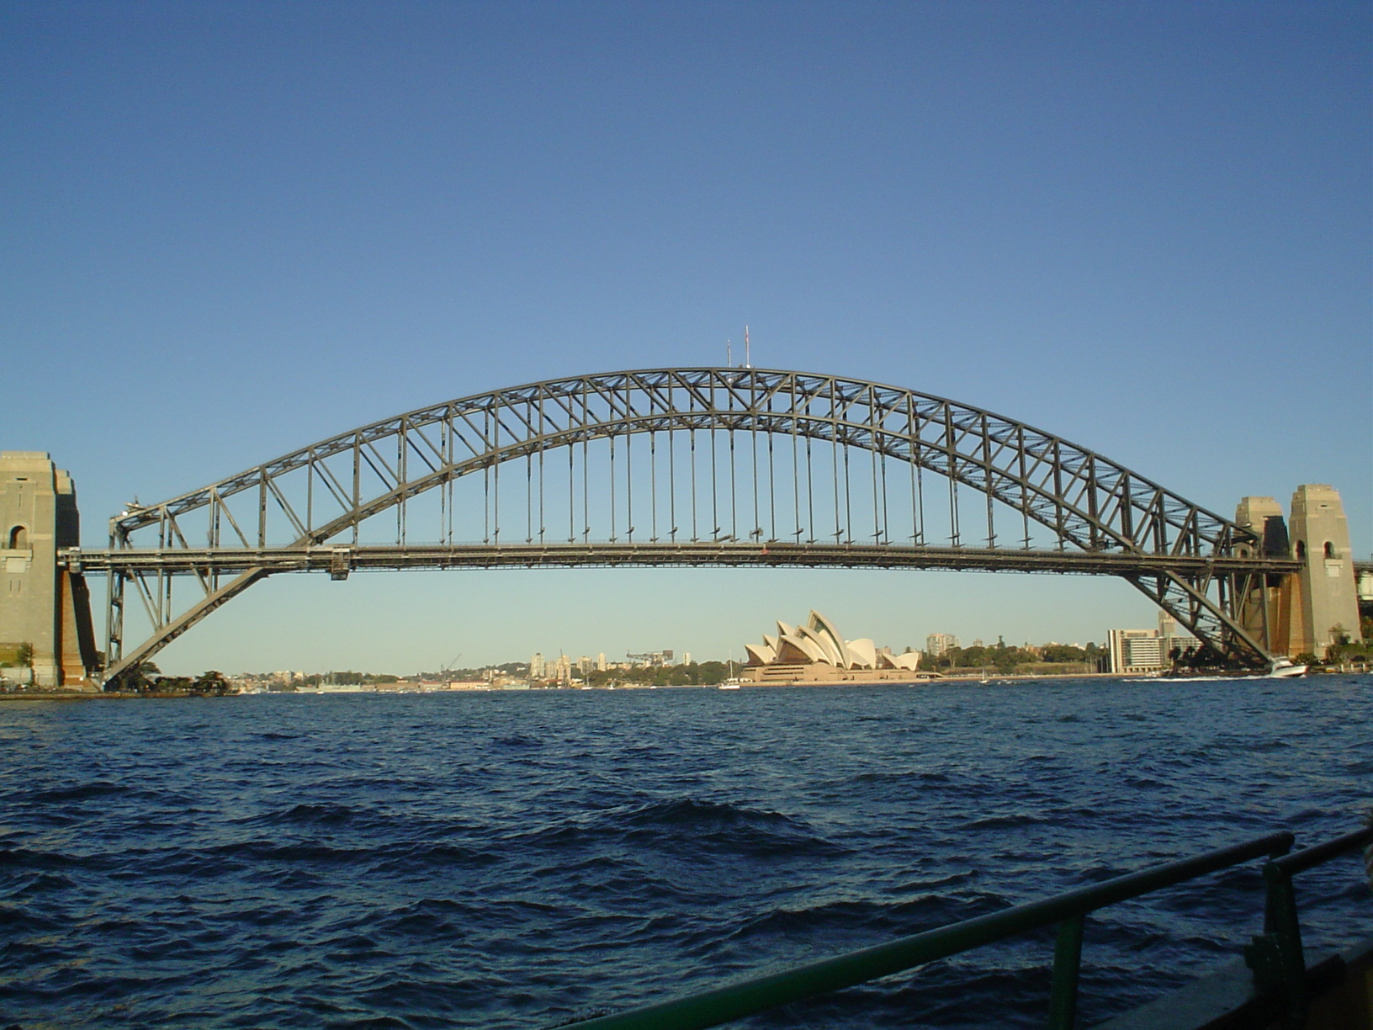
The consequences of pollution are far-reaching and call for immediate action. Governments, industries, and individuals must work together to reduce pollution levels and mitigate its effects. Implementing stricter regulations, promoting sustainable practices, and raising awareness about the importance of environmental conservation are crucial steps towards a cleaner and healthier planet.

